 News Release

For Release: Immediately

Contact:
Melanie French
Marketing Communications Manager
Phone +44 (0)1494 455432
Email: mfrench@parker.com

Parker’s New Thermal Gap Pad Combines 12.0 W/m-K Conductivity with Low Oil Bleed

High-Performance THERM-A-GAP™ PAD 120LOE provides long-term reliability for mission-critical electronic systems

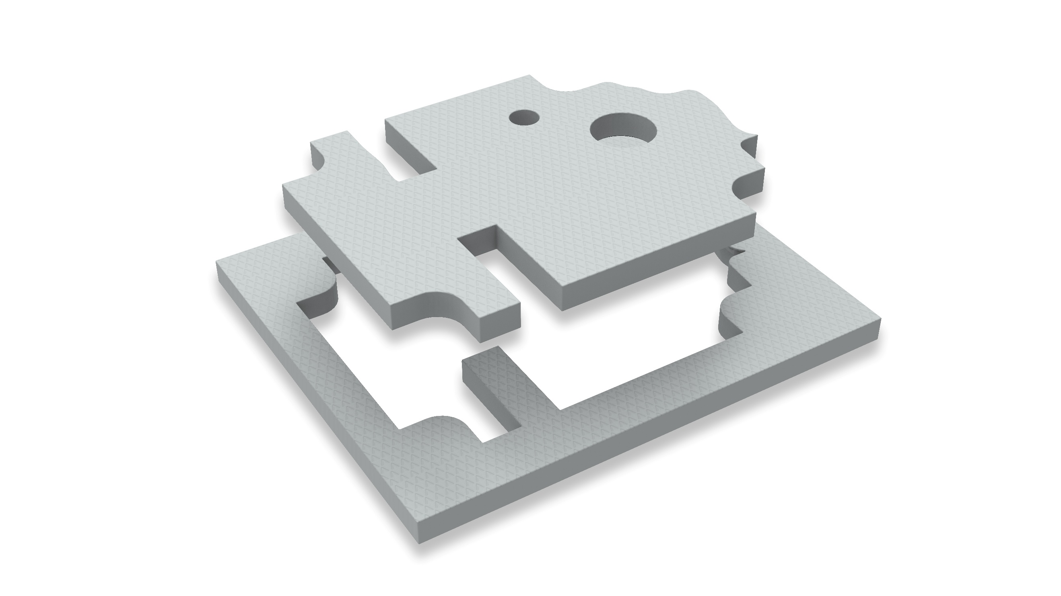

High Wycombe, Bucks, UK, 10 November 2026 – The Chomerics Division of Parker Hannifin is releasing THERM-A-GAP™ PAD 120LOE, a high-performance thermal gap filler pad with thermal conductivity of 12.0 W/m-K and exceptionally low silicone oil bleed and migration characteristics. The material is designed for mission-critical and high-performance electronics applications where the aesthetic or manufacturing issues associated with silicone oils can present challenges.

Offering a hardness of 45 Shore 00 (ASTM D2240 test method), the material provides excellent stress relaxation and imparts very low compressive force on sensitive components. it maintains effective thermal contact in applications with uneven surfaces or gaps, while also delivering vibration dampening and physical protection.

Applications include GPUs, CPUs and memory modules, as well as network devices, 5G and telecommunications equipment, automotive sensors and electronics, battery and energy storage modules and defence systems.

A high-tack surface reduces thermal contact resistance, and the material is electrically isolating. Properties include dielectric strength of 8 kV_{AC}/mm and volume resistivity of 10¹⁴ Ω-cm. It also offers a dielectric constant of 6.0 and a dissipation factor of 0.0001 (CHO-TM-TP13), both at 1,000 kHz and 1.2 mm thickness.

The new material has UL 94 V-0 flammability rating, RoHS compliance and an operating temperature range of -50°C to +200°C.

Standard thicknesses span 1 to 5 mm and the material can be supplied in 254 x 381 mm sheets or as custom die-cut parts. Requests for bespoke widths, lengths and part sizes can also be accommodated.

Learn more about THERM-A-GAP™ PAD 120LOE at https://ph.parker.com/gb/en/product-list/therm-a-gap-pad-120loe-thermally-conductive-gap-filler-pads

###

November 2026 Ref: PAREU1169/D/ENG

