 News Release

For Release: Immediately

Contact:
Melanie French
Marketing Communications Manager
Phone +44 (0)1494 455432
Email: mfrench@parker.com

New Parker Chomerics 3.0 W/m·K Thermal Gap Filler Pad Provides Excellent Rebound and Reusability

THERM-A-GAP® PAD 30RB maintains thermal performance even after repeated compression cycles

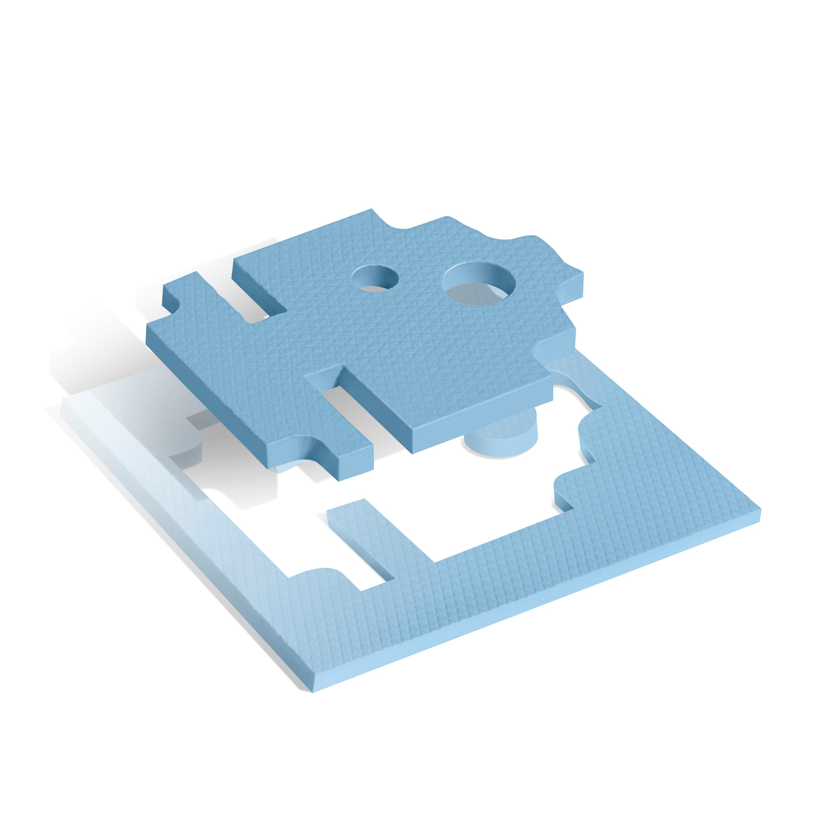

High Wycombe, Bucks, UK, 27th October 2026 – The Chomerics Division of Parker Hannifin, is launching THERM-A-GAP® PAD 30RB, a thermally conductive gap filler pad with excellent low compression force conformability and rebound characteristics. Offering thermal conductivity of 3.0 W/m-K, users can compress and reapply the material multiple times with minimal loss of thickness while maintaining thermal performance.

Designed to accommodate high stack-up tolerances, THERM-A-GAP® PAD 30RB helps minimise compressive loads and absorb mechanical shock and vibration. It is ideal for applications where components require reliable thermal management and with more than one assembly cycle.

Applications for the new material include chipset testing, automotive electronics, telecommunications equipment, consumer electronics and computing devices including desktop PCs, laptops and servers.

THERM-A-GAP PAD® 30RB is naturally tacky on both sides allowing secure positioning during assembly. It is also available with one non-tacky surface.

Thermal impedance is 2.9 °C-cm²/W, while electrical properties include dielectric strength of 0.02 kVac/mm (ASTM D149 test method) and volume resistivity of 10¹³ Ω-cm (ASTM D257). The RoHS-compliant material has an operating temperature range of -55°C to +200°C, carries a UL 94 flammability rating and has a shelf life of 24 months.

Thicknesses available range from 0.51 to 5.08 mm (in 0.254 mm increments) and the material is supplied in standard 228.6 x 228.6 mm sheets with custom widths, lengths and die-cut parts also available.

Carrier options include aluminium foil or Kapton®, with parts available with or without pressure-sensitive adhesive (aluminium foil carrier only).

Learn more about THERM-A-GAP® PAD 30RB at https://discover.parker.com/chomerics-pad30rb .

###

October 2026 Ref: PAREU1168/D/ENG

