**Shrinking the Next Generation of IoT Applications**

Industry predictions forecasted early generations of IoT applications like Smart Homes, Wearables, Smart Cities, the Connect Car and others. The next generation with merge the real with the virtual leveraging the synergies of ubiquitous connectivity, cloud computing and Big Data. Early IoT growth was driven by the individual. The next phase of IoT evolution prompts the next industrial revolution – Industry 4.0.

Achieving the innovation Industry 4.0 demands forces new approaches to legacy challenges. Connectivity and automation across the enterprise reign supreme. Disparate systems require integration. Stand-alone interfaces and processes need standardization. New technologies call for research, development and commercialization. New partners and new suppliers necessitate vetting.

Emerging examples from legacy industries adopting new approaches continue to appear. In recent years, Lufthansa Technik has collaborated with academia, start-ups and in-house specialists to adopt Industry 4.0 concepts in their landing gear, engines and maintenance divisions. This collaboration has developed various concepts from displaying remote sensor data on mobile devices to efficiently linking different IT systems.

The revolution of Industry 4.0 and the growth of the IoT demand advanced microelectronics innovation. Cutting-edge applications depend on customized, ruggedized or precision microelectronic packaging and assembly. OEMs across industries consistently strive to lessen their hardware footprint. Advanced solutions call for increased functionality and integration. Some products blend all of these requirements seamlessly.

The technology trends driving Industry 4.0 and the IoT force adaptation from traditional OEM suppliers. Samtec, a global manufacturer of a broad line of electronic interconnect solutions, has developed a growing portfolio of advanced microelectronic capabilities. Samtec Microelectronics combines complex IC packaging and assembly, the superior performance benefits of glass substrates and high frequency design with system level signal integrity to develop next generation microelectronics solutions.

Samtec's innovative, world-class products and technologies are optimized for performance, density and cost in various Industry 4.0 applications. Samtec Microelectronics capabilities include advanced IC packaging and assembly, Glass Core Technology™, nMode™ modules and components and microelectronic design services

**Advanced IC Packaging and Assembly**

Samtec Microelectronics is a world-class provider of advanced IC packaging and assembly. Samtec partners with OEMS in the medical, industrial and other IoT application developers around the world whose solutions require increased performance, higher reliability, longer lifetimes and rugged connectivity.

Samtec core IC packaging and assembly capabilities include maximum density flip chip and underfill, precision placement die attach, ultra-fine pitch and low profile wirebonding and various finishing capabilities including dam and encapsulation. Table 1 outlines key design features Samtec supports in each capability.

**Shrinking the Next Generation of IoT Applications**

|  |  |  |  |
| --- | --- | --- | --- |
| **Flip Chip & Underfill** | **Die Attach** | **Wirebonding** | **Dam & Encapsulation** |
| Accuracy to +/-3 microns | Accuracy to +/-3 microns | Ultra-fine pitch, ultra-low profile ball bond & wedge bond | Automated or manual encapsulation |
| Manual, semi-automated & automated | Manual, semi-automated & automated | Wire diameters from 19 µm to 50 µm DIA | Dual-head dispensers |
| Ceramic, laminate, HiTCE and Si on Si substrates | High speed, high accuracy dispense & placement systems | Au, Al, Pt and Cu wires | Temperature control of fluids and substrates |
| Gold stud bump thermocompression flip chip | Fillet control per MIL-STD 883 | SSB (stitch standoff on ball), security bonds and constant gap wedge bonding | Low out-gassing, low stress & custom materials |
| Solder flip chip (Eutectic, high Pb, Pb-free RoHs) | Epoxy attach | Stacked die wire bonding | Custom processing |
| Thermocompression flip chip | Isotropic & anisotropic adhesives, low out-gassing, low stress & custom materials, UV cure adhesives, dicing die-attach films | Multi-chip modules | Thermal or UV cure |
| Adhesive attach flip chip (anisotropic Z-axis adhesives and films) | Custom processing | Signal Integrity support | CSAM validation: in-house acoustic microscopy analysis |
| Capillary and jet underfill | Dispensed, tapes or preforms |  | Laser marking/ink marking |
|  | CSAM validation: in-house acoustic microscopy analysis |  | Conductive/non-conductive lids |
|  |  |  | Automated & manual lid attach |
|  |  |  | Hermetic sealing |

Table 1 - Samtec Microelectronics IC Packaging and Assembly Capabilities

**Shrinking the Next Generation of IoT Applications**

In addition to basic IC packaging and assembly processes, Samtec unmatched design support in advanced IC packaging and assembly applications. Some of these design services include:

* Package Design & Analysis:
  + Simulation of critical channels to validate implementation and signaling requirements
* Power Integrity:
  + AC & DC power delivery analysis; recommendations for via placement, copper thickness and bypass capacitors
* PCB Transition Structures:
  + Designs engineered to minimize signaling effects of transitions from package to PCB
* Complex Packaging & Substrate Design:
  + Custom 2D, 3D, stacked die, MCMs, MEMS, Microfluidic MEMS
* In-house Optics Expertise:
  + Support for applications integrating ICs with high-performance optical assemblies

In combination with Teraspeed® Consulting, Samtec also offer development partnerships and complete program support for the entire product life cycle from concept through the design phase into small prototype builds and into full-volume production. This collaboration offers unprecedented support for advanced microelectronics packaging design, simulation and analysis expertise that enables IC application optimization.

**Glass Core Technology™**

Advanced IC packaging and assembly techniques customized for specific applications will remain an option for OEMs innovating optimized performance. Numerous emerging Industry 4.0 and IoT applications have reduced form-factors specifications. Material selection at the IC and substrate level can influence the system-level performance and size for these solutions.

Glass substrates are quickly becoming an ideal solution in these areas. Glass provides many benefits when compared to traditional compared to traditional silicon and organic substrates. It is an excellent low loss, lower cost solution. It provides a solid processing infrastructure for IC packaging applications.

Additional benefits of glass substrates include:

* Electrical conductivity
* TCE match to the glass
* Increased reliability of large I/O dies with fine pitches
* Low warp
* Hermetic Cu-based vias
* Reduced wafer breakage
* Thermal cycling reliability
* Improved thermal conductivity vias for logic, power or other applications

Samtec’s Glass Core Technology™(GCT) is a proprietary process that leverages the performance benefits of glass by creating small diameter, fine pitch, high density metalized and hermetically sealed Through-Glass Vias (TGVs). Benefits of the TGVs include:

**Shrinking the Next Generation of IoT Applications**



* Hermetic / high conductivity vias
* Miniaturization
* 100 µm (0.1 mm) pitch, with roadmap to 40 µm (0.04 mm)
* 40 µm (0.04 mm) diameter, with roadmap to 10 µm (0.01 mm)
* Laser formed holes
* 200+ µm (0.2 mm) thick glass

Figure 1 High Density TGV Metalization

* Optimized coplanarity (< 20 µm wafer bow)

Samtec offers three types of TGVs: tapered, hourglass and straight. TGV type is dependent upon industry and application requirements. TGVs enable TGV wafers and interposer die. TGV wafers permit the integration of glass and metal into a single wafer, while interposer die permit more efficient connections and cycle times. The hermetically sealed wafers are manufactured from both high quality borosilicate and quartz glass. Through the use of high quality wafer material, combined with top metalization technology, Samtec wafers become a one of a kind packaging product.



The TGVs are linked via a unique thin film Redistribution Layer (RDL) process. This technique enables circuit patterning over the top and bottom of glass substrates. This process provides a low loss, fan-out of chip and package interconnects at a lower cost than silicon interposers.

The result is a performance optimized, ultra-miniaturized substrate, ideal for next generation IC packaging. GCT achieves maximum functionality in a significantly smaller footprint with glass-based IC packages, modules, and components compared to traditional IC packaging substrates. GCT also enables faster cycle times and KGD testing at higher packaging integration levels, at the lowest cost in the marketplace.

Figure 2 RDL Circuit Patterning

New and exciting applications leveraging GCT continue to emerge. Biomedical sensors with IoT connectivity can be assembled by wafer level processing. GCT provides an excellent packaging platform for incorporating optical waveguides and tuning mirrors for many advanced optical applications used in various connectivity applications.

**nMode™ Modules and Components**

Advanced IC packaging and assembly capabilities and services and the size reduction of glass substrates are tools that OEMs innovating for industry 4.0 can leverage individually. Combing assembly and packaging technique and glass substrates with system level design provided the ideal platform for IoT application developers to leverage on next generation products

**Shrinking the Next Generation of IoT Applications**

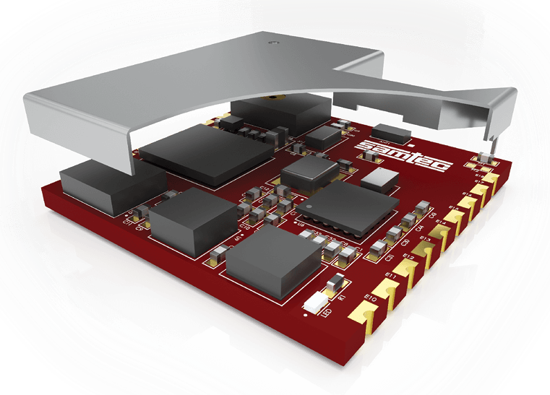

One of the first solutions available combining all of these capabilities is the Samtec nMode™ Wireless Sensor Module. This new module enables remote sensing and measurement of inertial, environmental, and acoustical parameters. Leveraging standard ICs, Samtec’s pre-engineered modules integrate industry standard, fully tested and certified wireless, microcontroller and sensor components.

The small size and powerful design make the nMode™ Wireless Sensor Module as a standalone node ideal for products such as wearables, gaming accessories, and smart-home or any number of IoT applications. The modular design affords easy, functional customization during design and development and significantly reduces time to market for production.

Figure 3 nMode™ Wireless Sensor Module OSM-1-1313

Samtec has collaborated with STMicroelectronics to position the nMode™ Wireless Sensor Module as an FCC-certified production version of ST’s SensorTile development kit. The Samtec solution leverages standard ICs and, like ST’s SensorTile, it’s compatible with the STM32 ecosystem through STM32Cube support. This approach to IoT application development enable OEMs to focus on their core IoT application competencies while shortening design cycles and time to market for IoT application developers.

Samtec continues to explore new applications at the module and component level. This includes the packaging of modules and other high performance components with a glass substrate. This revolutionary process enables performance optimized, ultra-miniaturized IC packages and modules. In addition to wireless sensor modules, discrete components like filters, inductors and antenna appear feasible.

**Conclusion**

The next phase of IoT evolution is here. Next generation IoT developers must consider alternative approaches to product and solution development. As an emerging solution provided to the IoT, Samtec Microelectronics combines complex IC packaging and assembly, the superior performance benefits of glass substrates and high frequency design with system level signal integrity to develop next generation microelectronics solutions. Samtec's innovative, world-class products and technologies are optimized for performance, density and cost in various IoT applications.

Author bio:

*Matt Burns is Samtec’s Product Marketing Manager. He develops go-to-market strategies for Samtec’s Silicon to Silicon solutions, and over the course of the last 18 years he has been a leader in design, technical sales and marketing in the telecommunications, medical and electronic components industries. Mr. Burns holds a B.S. in Electrical Engineering from Penn State University.*