SEARAY™ High-Density Arrays Maximize Routing and Grounding Flexibility

These high speed, high density open-pin-field arrays (SEAM, SEAF), on a 1.27 mm pitch grid, allow maximum grounding and routing flexibility.

Interconnect systems are available with up to 560 single-ended I/Os or 140 differential pairs, and in stack heights from 7 to 40 mm. The rugged Edge Rate® contact system is less prone to damage when “zippered” during unmating.

SEARAY is available in parallel, perpendicular (right angle), and coplanar (horizontal) orientations. Solder charges are standard on each tail for ease of processing, to create IPC-A-610F and IPC J-STD-001F Class 3 solder joints. Press-fit tails are also available.

High-speed cable assemblies for 50 Ω or 100 Ω solutions are available. VITA Standards specify configurations of SEARAY high-speed array products for VITA 57.1, VITA 57.4, and VITA 74.

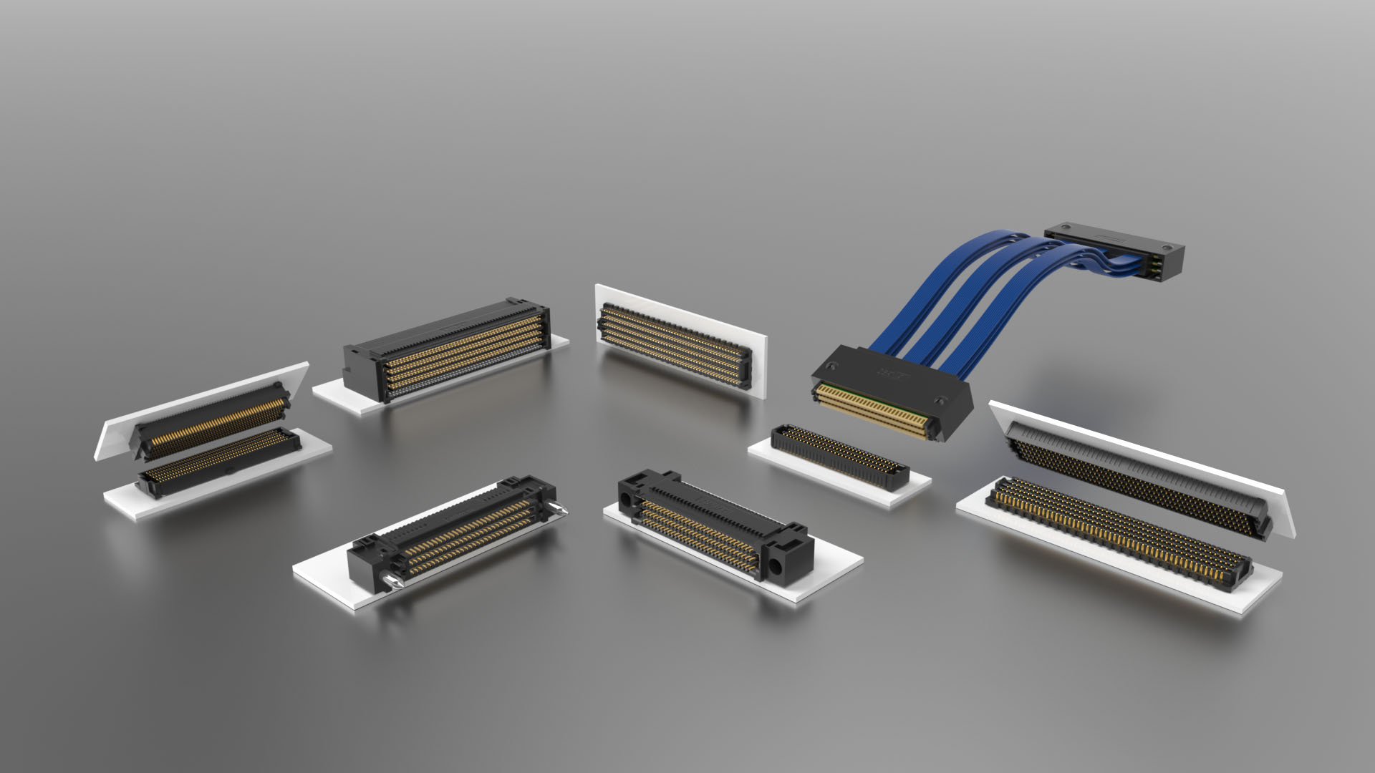

For more information about SEARAY click here:
https://www.samtec.com/connectors/high-speed-board-to-board/high-density-arrays/searay

For more information about SEARAY products in VITA Standards, click here:
https://www.samtec.com/standards/vita

About Samtec
Founded in 1976, Samtec is a privately held, $1 Billion dollar global manufacturer of a broad line of electronic interconnect solutions, including High-Speed Board-to-Board, High-Speed Cables, Mid-Board and Panel Optics, Precision RF, Flexible Stacking, and Micro/Rugged components and cables. Samtec Technology Centers are dedicated to developing and advancing technologies, strategies, and products to optimize both the performance and cost of a system from the bare die to an interface 100 meters away, and all interconnect points in between. With 40+ international locations and products sold in more than 125 different countries, Samtec’s global presence enables its unmatched customer service. For more information, please visit: www.samtec.com.
Our press team enjoys working with journalists around the world to share compelling and innovative stories. If you are a member of the media/press and would like to talk, please send an email to mediaroom@samtec.com.

