Samtec NovaRay® Cable Assembly Delivers PAM4 Signals in Dense Designs

Innovative, fully shielded differential pair design enables extremely low crosstalk and tight impedance control.
Samtec, Inc., the service leader in the connector industry, has announced availability of its NovaRay® cable assemblies that combine extreme density and performance by using 40% less space than traditional arrays to support 112 Gbps PAM4 per channel. Applications include datacom, AI/ML, HPC, computer and semiconductor, medical, test and measurement, military/aerospace, and mobile networks.
Samtec’s NovaRay cable assemblies enable extremely low (<30 dB, FEXT and NEXT) crosstalk out to 40 GHz. Operating across -40 to +125˚C, the NovaRay cable assemblies (part number NVAC) are PCIe®6.0/CXL® 3.1 capable.

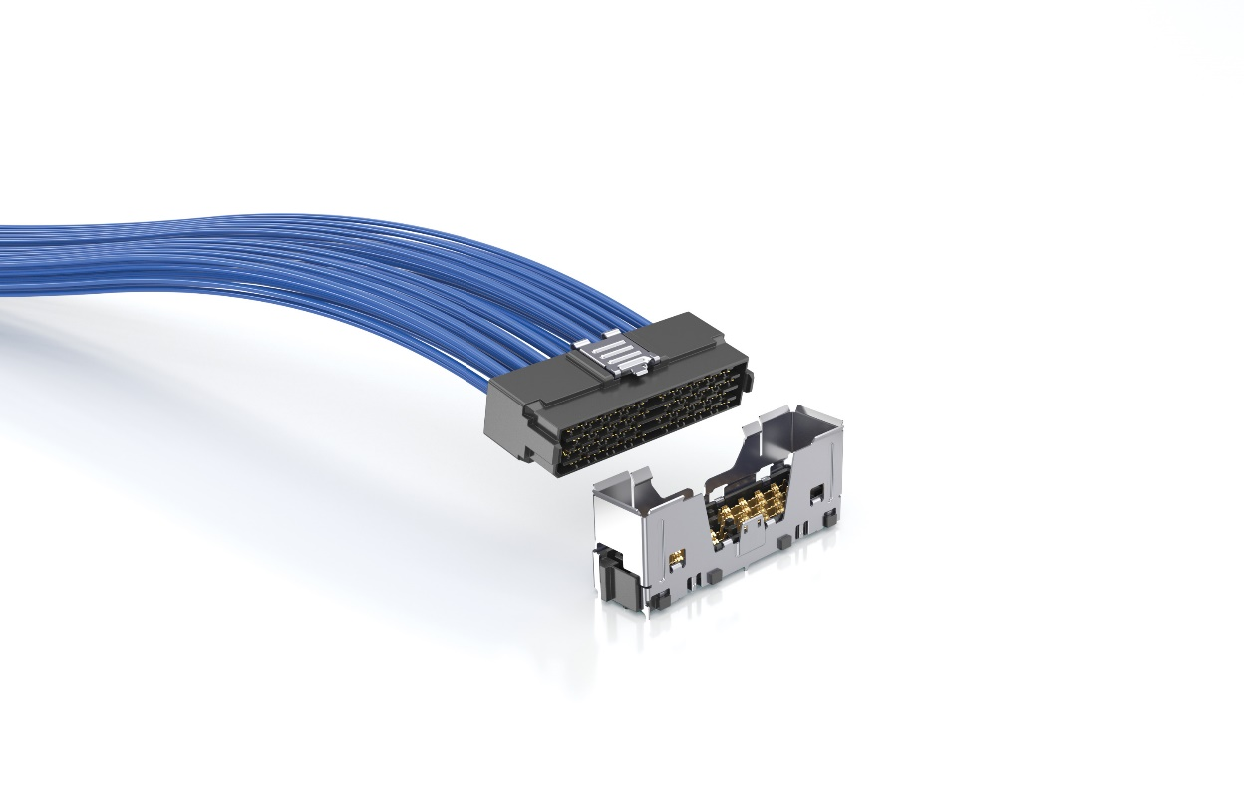
The innovative design of the Samtec NovaRay connector combines extreme performance with extreme density, which is critical as speeds increase and system sizes decrease. The fully shielded differential pair design and two reliable points of contact contribute to its industry-leading 4.0 Tbps aggregate data rate. The NovaRay cable assemblies include two connectors and are available with optional shielding and latching systems. While End 1 of the NovaRay cable assembly includes a NovaRay connector, designers can select from a variety of End 2 options from the Samtec catalog depending on their application, including FQSFP, NovaRay I/O, ExaMAX® backplane, and upcoming NovaRay backplane.
NovaRay cable assemblies are available with 34 AWG EyeSpeed® ultra-low-skew twinax cable (<3.5 ps/meter). Options include 34 AWG/100 Ω, 34 AWG/92 Ω, and 34 AWG ThinaxTM/92 Ω ultra-performance cable (with a 40% smaller cross-sectional area). The 92 Ω solutions address both 85 Ω and 100 Ω applications.
Samtec’s NovaRay cable assemblies are in stock and available now, directly from Samtec or through authorized distributors. Samtec SI experts can be reached directly for design assistance at sig@samtec.com

About Samtec, Inc.
Founded in 1976, Samtec is a privately held, $1 Billion dollar global manufacturer of a broad line of electronic interconnect solutions, including High-Speed Board-to-Board, High-Speed Cables, Mid-Board and Panel Optics, Precision RF, Flexible Stacking, and Micro/Rugged components and cables. Samtec Technology Centers are dedicated to developing and advancing technologies, strategies, and products to optimize both the performance and cost of a system from the bare die to an interface 100 meters away, and all interconnect points in between. With 40+ international locations and products sold in more than 125 different countries, Samtec’s global presence enables its unmatched customer service. For more information, please visit: http://www.samtec.com.

