Samtec AcceleRate® Slim Cable Assemblies Save PCB Space, Support PCIe® 6.0/CXL® 3.1
Available now in production quantities, Samtec AcceleRate Slim Direct-Attach Cable Assemblies target high-density applications in computing, datacom, AI, and shielded Gigabit Ethernet designs.

Samtec, Inc., the service leader in the connector industry, announces availability in production quantities of AcceleRate®Slim Direct-Attach Cable Assemblies, the industry’s slimmest cable system. Measuring 7.6 mm wide, the Samtec AcceleRate interconnect system saves valuable PCB space, is rated at 64 Gbps PAM4 (32 Gbps NRZ) speeds, and is PCIe® 6.0/CXL® 3.1 capable.
The AcceleRate cable assembly features Samtec’s proprietary 34 AWG, 100 Ω Eye Speed® ultra-low skew twinax cable, which enables its slim footprint. The ultra-low skew twinax cable routes signals off the board and is a key performance enabler as signal reach and integrity become increasingly important in high-speed applications. Each design is unique, so Samtec works with system architects early in the process to create solutions for cable management and thermal load distribution.

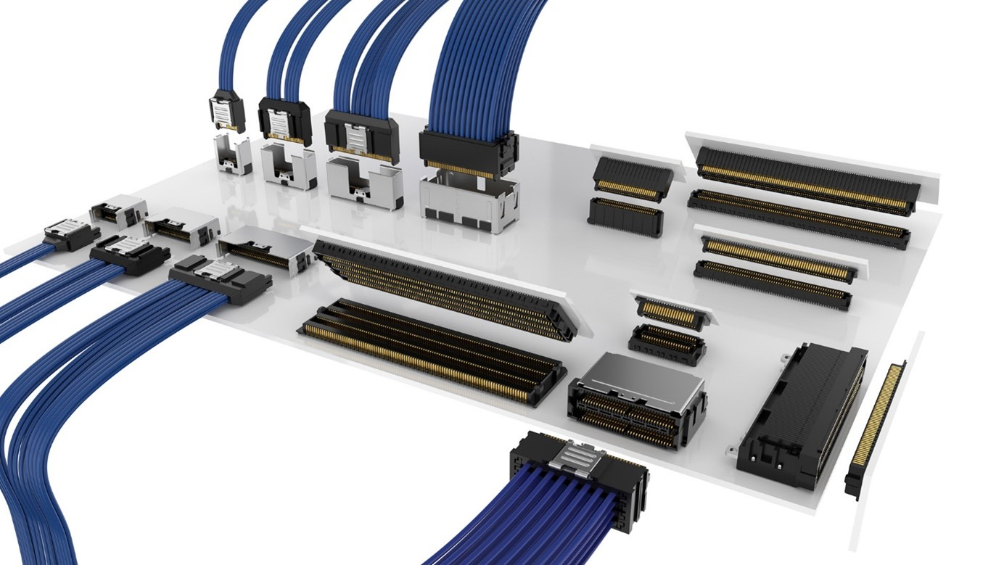

AcceleRate interconnects use direct attach technology to connect with the contacts, resulting in improved signal integrity while eliminating the need for (and variability of) a transition card. For increased stability on the PCB, the AcceleRate mating board level slim socket connector (ARF6) and cable assembly (ARC6) system include rugged metal latching and shielding as well as through-hole weld tabs.

Samtec AcceleRate® Slim Cable Assemblies Save PCB Space, Support PCIe® 6.0/CXL® 3.1

AcceleRate Slim Cable Assemblies are available in 8, 16, and 24 differential pair options. The 16 differential pair option supports PCIe® x4 plus sidebands, and the 24 differential pair option supports PCIe® x8 plus sidebands. A “Reversed Polarity” pinout option reduces far-end crosstalk (FEXT).
Samtec ARC6, ARF6 high-density cable system is in stock and available now in production quantities directly from Samtec or through authorized distributors. These products are also part of the Samtec Reserve program, with shipments occurring in 24 hours. As the service leader in the connector industry, Samtec makes designing-in the right product solution easy by offering free 3D model downloads and product samples. For an more information on AcceleRate, visit https://www.samtec.com/solutions/accelerate/.

About Samtec
Founded in 1976, Samtec is a privately held, $1 Billion dollar global manufacturer of a broad line of electronic interconnect solutions, including High-Speed Board-to-Board, High-Speed Cables, Mid-Board and Panel Optics, Precision RF, Flexible Stacking, and Micro/Rugged components and cables. Samtec Technology Centers are dedicated to developing and advancing technologies, strategies, and products to optimize both the performance and cost of a system from the bare die to an interface 100 meters away, and all interconnect points in between. With 40+ international locations and products sold in more than 125 different countries, Samtec’s global presence enables its unmatched customer service. For more information, please visit: www.samtec.com.
Our press team enjoys working with journalists around the world to share compelling and innovative stories. If you are a member of the media/press and would like to talk, please send an email to mediaroom@samtec.com.

