Press Release ELESTA GmbH

Relay product range

**1 + 1 = 1?**

Relay series SID3 - New 3-pole double armature relay with forcibly guided contacts!

ELESTA GmbH is expanding its SID series of double-armature relays with a space-saving 3-pole version, the SID3. The 3-pole double armature relay with two independent forcibly guided contact sets has two NO contacts and one NC contact. In accordance with IEC 61810-3, these relays are predestined for dual-channel functional safety control systems up to SIL3 (IEC 61062) or PL ‘e’ (ISO 13894).

With a footprint of 45.7 mm x 10.9 mm, the SID3 requires around 18% less space than two comparable mounted standard relays. The reduction in the number of connection pins from 16 to 8 simplifies wiring and optimises the layout. In addition, an area of 240 mm2 is available under the relay, which can be used for components up to 3 mm in height.

The SID3 also scores highly in terms of sustainability. The weight is reduced by a total of 7%, with plastic accounting for the largest proportion at 23%. If the ELOPIN version is also used, there is no need for an additional soldering process, which saves resources. The optimised design of the relay enables a significantly lower energy requirement compared to typical relay designs: 37% lower nominal coil power (~ 600 mW) and 25% (~ 90 mW) lower coil holding power. Available coil voltages range from 5 VDC to 110 VDC.

Author: Jürgen Steinhäuser / Head of Sales and Marketing

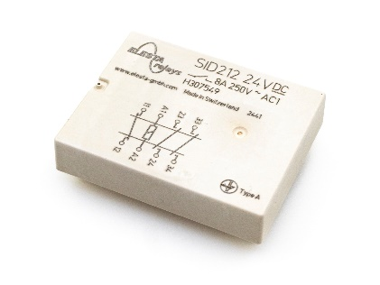

*Caption: SID212 - Double armature relay with forcibly guided contacts*

Photo: ELESTA GmbH, Bad Ragaz

Further information:

ELESTA GmbH, Heuteilstrasse 18, CH-7310 Bad Ragaz, Tel.: + 41 81 303 54 00, Fax: + 41 81 303 54 01,

E-mail: admin@elesta-gmbh.com, Homepage: www.elesta-gmbh.com

**Please send us your copy after publication!**